STOCK MARKET PREDICTION: MODEL DEVELOPMENT.

Major Steps In stock market prediction model development.

**Data Loading (Apple Stock Data)**

**EDA.**

1. **Correlation** and **Heatmap** construction.
2. **Box Plot** of each column.
3. Scale Data values using **Min Max. Scaling.**

**Preprocessing.**

1. **Data type conversion** of column Date to Datetime.
2. Handling **Missing values.**
3. **Duplicate Value** Checking.

**Data Preprocessing & EDA**

**Model 1: LSTM + LR**

**Model 2: LSTM + LR + SVR + RF**

**LR- All Features & LSTM- 60 Days Close Price**

**LR- OHL & LSTM- All Features**

**LR- LFM & LSTM- 60 days close price.**

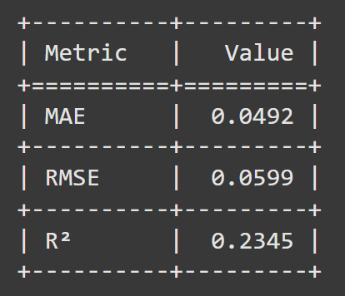

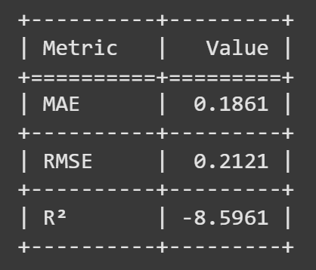

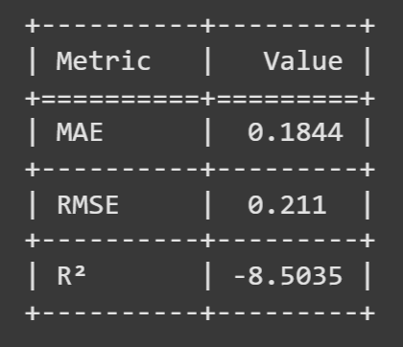

**LR, LSTM, SVR and RF-OHL**

**LR, LSTM, SVR and RF uses all features.**

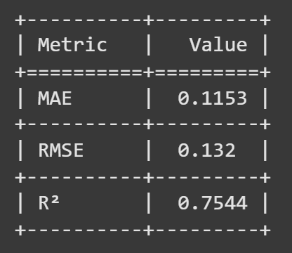

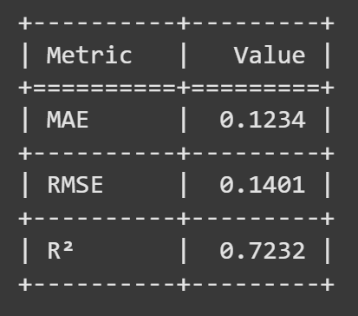

**LR, SVR and RF-LFM & LSTM- 60 days close price.**

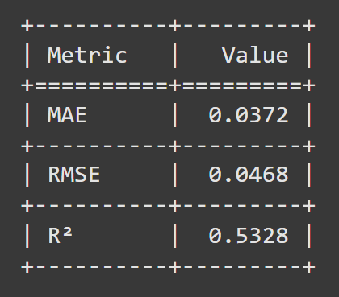

**Model 2: LSTM + LR + SVR + RF**

**Model 3: Voting Regressor**

**LR, SVR, RF-OHL**

**LR, SVR, RF-OHLVA**

**LR, SVR and RF-LFM & LSTM- 60 days close price.**

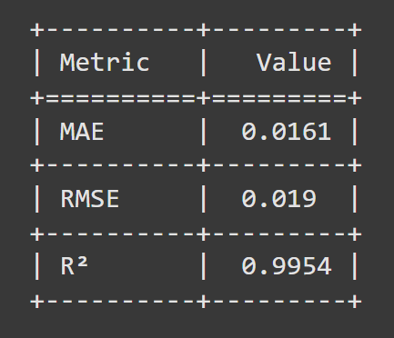

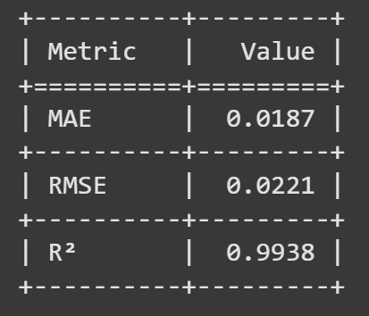

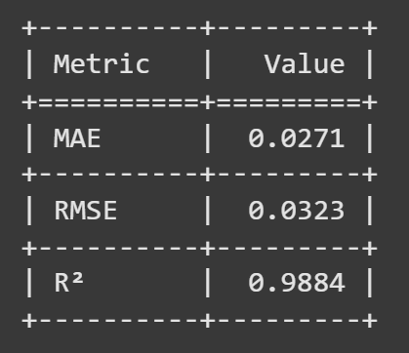

**Final Comparison of Model’s Results.**

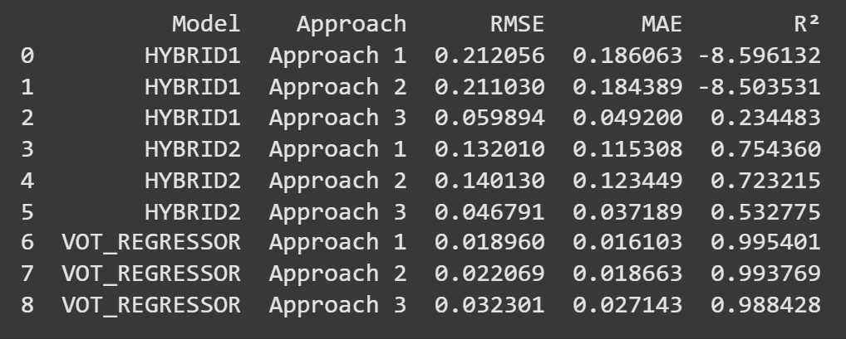

* OHLVA: Open, High, Low, Volume, Adjusted Close.
* LFM: Lag Feature Method.
* OHL: Open, High, Low.